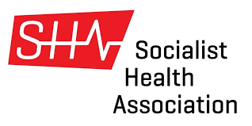
SHA – Election 2025
Central Council Members

- Dr Brian Gibbons
- Terry Harper
- Julius Marstrand
- Harry Stratton
- Carmel Cadden
- Mark Howell
- Judith Kramer
- Liz Peretz
- Carmen Williams
- Pat Schan
- Adrian Scandrett
- Pam Wortley
- Caroline Bedale
- Tony Beddow
- Julian Williams

